**4.1 Build Custom Docker Image**

1. Clone the given git repo Using command (I used repo that gave in assisted doc)

git clone <https://github.com/Anuj1990/Docker.git>  
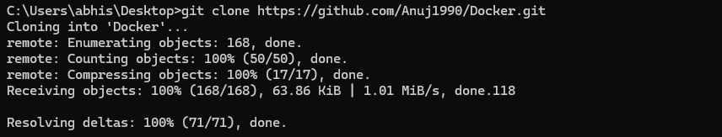

1. Now go to the cloned repo and then build the image using the below command:  
   docker build -t phpcode  
     
   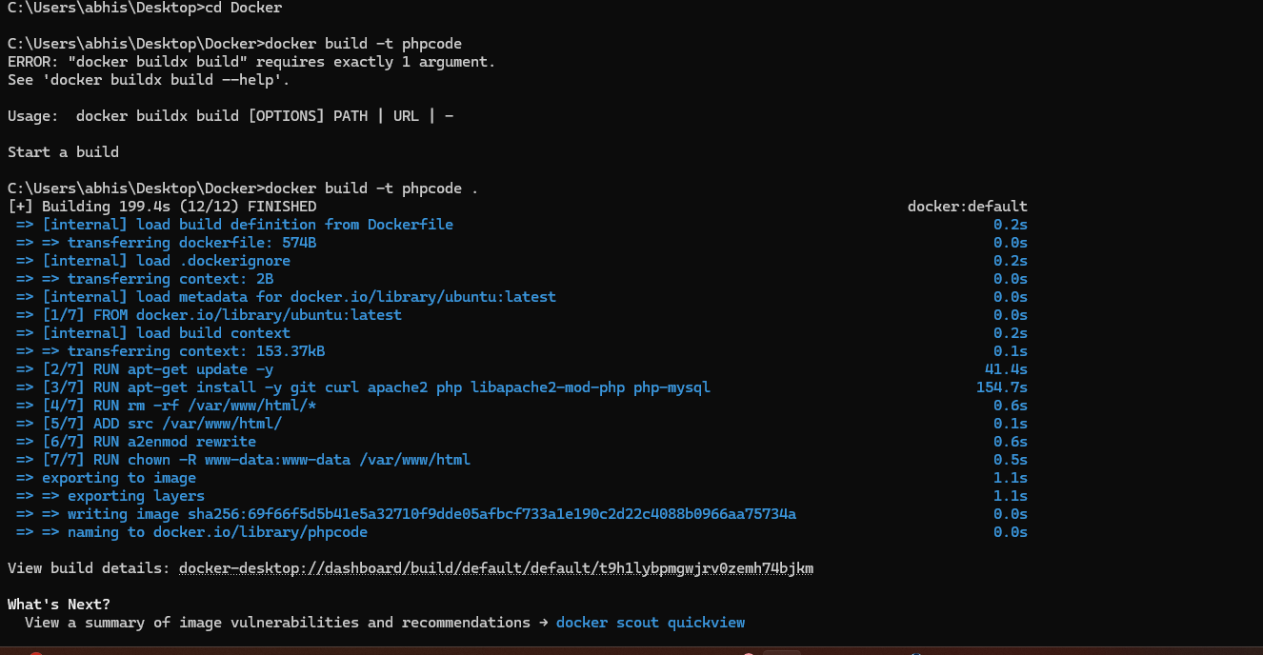
2. Now we can see the build image using the below command:

docker images

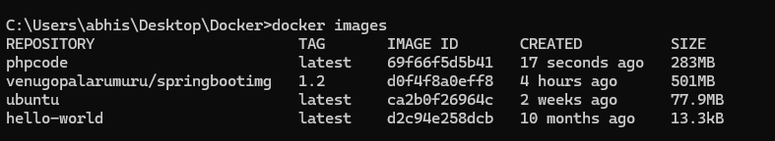

1. Now run the image using the below command:

docker run -d --name phpcode -p 80:80 phpcode  
  
